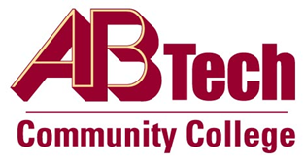

# Asheville-Buncombe Technical Community College (A-B Tech) Policy Manual

## Policy 213: Instructional Live Projects

It is the policy of the Board of Trustees that the College will adhere to North Carolina State Board of Community College Code governing instructional live projects.

Scope

Applies to curriculum and continuing education classes.

Definitions

### Instructional Live Projects:

Educational programs in which students, as part of their educational experiences, and as part of their instructional course requirements, repair or remodel non-college owned personal property or real property; or

Educational programs that construct structures that are sold, produce goods that are sold, or provide services for a fee, such structures, goods or services being the normal and necessary product of learning activities of students.

References

1H SBCCC 300.1 Live Client Projects

Reviewed by the Executive Leadership Team, November 29, December 5 and 12, 2012, and July 18, 2018

Policy Owners

Primary: Vice President for Operations/CIO, Ext. 7900

Secondary: Vice President for Instructional Services, Ext. 7900, and Vice President for Economic & Workforce Development/Continuing Education, Ext. 7900

See Instructional Live Projects Procedure

Approved by the Board of Trustees on July 30, 2018.